**W.T. LAB-04**

**NAME:** TANGELLA MANOJ **CLASS:** SG-08

**ID NO:** N190171  **ROLL NO:** 14

**QUESTION:**

I Apply all these styles for different web pages.

Try to use a mix of the different types of selectors- id, class, position in document, etc.

• Create a webpage that prints your name to the screen, print your name

in different font styles, print a definition list with 5 items, Create links to

five different pages(pseudo-class selectors for links).

• Create a webpage and include no.of paragraphs and Change the color of

the element with id=&quot;para1&quot; to &quot;red&quot; in the same way use class and

universal selector.

• Set &quot;image&quot; as the background image of the page, and repeat it vertically

only and also Change the size of the background image to: width 100px,

height 80px.

• Set &quot;image&quot; as the background image of the page.

• Set the background color for the page to &quot;linen&quot; and the background color

for &lt;h1&gt; to &quot;lightblue&quot;.

• Set background image for both the page and single elements on page.

• Control the repetition of image with background-repeat property.

• Define style for links as a:link , a:active, a:hover, a:visited.

• Create a web page give it a background color of semi-transparent black,

resulting in a slightly darker shade that lets the background red color

shine through a bit too.

• Set the padding of the div to &quot;25px&quot;, Set the border of the div to &quot;25px

solid navy&quot; and Set the margin of the div to &quot;25px&quot;.

**code:-**

<!DOCTYPE html>

<html>

<head>

<title>A simple web</title>

<style type="text/css">

a{

text-decoration: none;

}

a:link{

color: green;

}

a:hover{

color: pink;

}

a:visited{

color: black;

}

a:active{

color: red;

}

/*body{

background-image:url("uwp2429018.jpeg");

width: 100px;

height: 80px;

}*/

.div{

width: 100px;

height: 100px;

background-color: black;

margin: 40px;

padding: 5px;

border: 4px solid blue;

}

</style>

</head>

<body background="">

<h4>Font-Styles</h4>

<P style="font-style:italic;">Manoj</P>

<P style="font-style:oblique;">Manoj</P>

<P style="font-style:initial;">Manoj</P>

<P style="font-style:inherit;">Manoj</P>

<P style="font-style:normal;">Manoj</P>

<h3>Definition List</h3>

<dl>

<dt>CSE</dt>

<dd><a href="https://www.google.com/search?q=cse&rlz=1C1CHBF_enIN1005IN1005&oq=cse&aqs=chrome..69i57j69i59j0i271l2j69i61l2j69i60.830j0j7&sourceid=chrome&ie=UTF-8">Computer science Engineering</a></dd>

</dl>

<dl>

<dt>ECE</dt>

<dd><a href="https://www.google.com/search?q=ece&rlz=1C1CHBF_enIN1005IN1005&oq=ece&aqs=chrome.0.69i59l3.1311j0j7&sourceid=chrome&ie=UTF-8">Electronic and Communications Engineering</a></dd>

</dl>

<dl>

<dt>CE</dt>

<dd><a href="https://www.google.com/search?q=civil+engineering&rlz=1C1CHBF_enIN1005IN1005&oq=civil+engineering&aqs=chrome..69i57j0i271.9731j0j7&sourceid=chrome&ie=UTF-8">Chemical Engineering</a></dd>

</dl>

<dl>

<dt>MME</dt>

<dd><a href="https://www.google.com/search?q=civil+engineering&rlz=1C1CHBF_enIN1005IN1005&oq=civil+engineering&aqs=chrome..69i57j0i271.9731j0j7&sourceid=chrome&ie=UTF-8">Materials and Metalargical Engineering</a></dd>

</dl>

<dl>

<dt>EEE</dt>

<dd><a href="https://www.google.com/search?q=eee&rlz=1C1CHBF_enIN1005IN1005&oq=eee&aqs=chrome..69i57j69i59.490j0j7&sourceid=chrome&ie=UTF-8">Electrical and Electronical Engineering</a></dd>

</dl>

<div class="div"></div>

<div class="div"></div>

<div class="div"></div>

</body>

</html>

**Output:-**



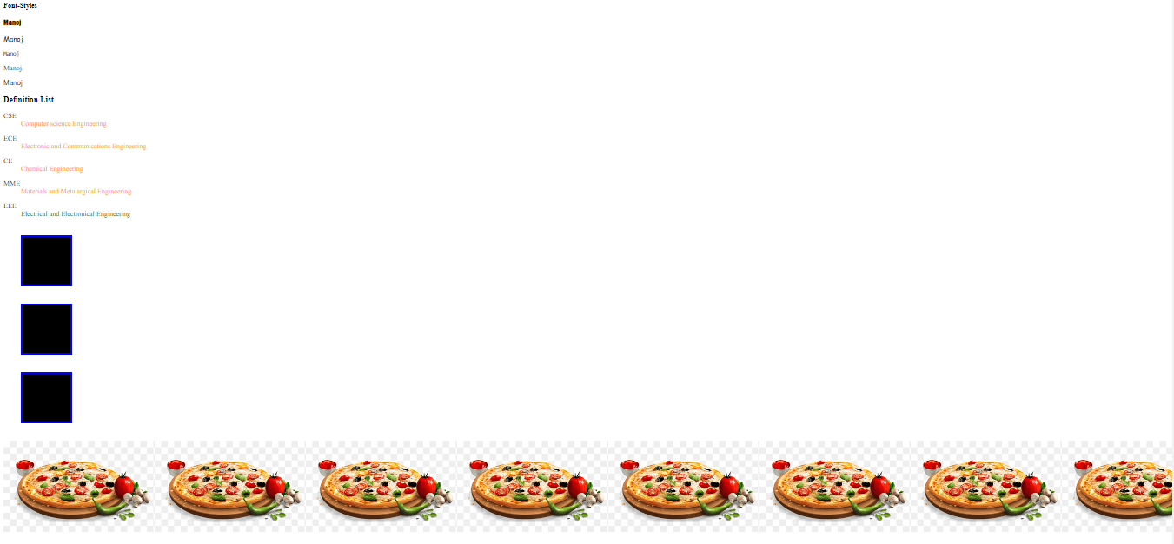

**QUESTION-2:-**

**1.** Check the login:

Write the code which asks for a login with prompt.

If the visitor enters &quot;Admin&quot;, then prompt for a password, if the input is an empty line or Esc –

show “Canceled”, if it’s another string – then show “I don’t know you”.

The password is checked as follows:

• If it equals “TheMaster”, then show “Welcome!”,

• Another string – show “Wrong password”,

• For an empty string or cancelled input, show “Canceled”.

**Code:-**

<!DOCTYPE html>

<html>

<head>

<title></title>

<style>

fieldset{

position: absolute;

margin-left:250px;

align:center;

border: 7px #bf1774;

border-style:outset;

background-color:#ffe6ff;

}

table{

border-spacing: 15px;

padding:0px;

}

body{

align-content: center;

align:center;

}

#sub{

border-radius: 50px;

border:2px solid red;

width:100px;

font-size: 16px;

background-image:linear-gradient(to right,skyblue,pink);

color: darkred;

}

p{

color:blue;

font-size:15px;

font-style:italic;background-image: linear-gradient(to right,yellow,pink);

border: 2px solid gray;

padding: 3px;

}

input[type=file]{

}

</style>

<script>

</script>

</head>

<body align="center">

<form>

<fieldset>

<legend><p>Form</p></legend>

<table align="center">

<tr>

<td>First Name:</td>

<td><input type="text" name="first" placeholder="First name"></td>

</tr>

<tr>

<td>Last Name:</td>

<td><input type="text" name="last" placeholder="Last name"></td>

</tr>

<tr>

<td>Gender:</td>

<td><input type="radio" name="gen">Male

<input type="radio" name="gen">Female</td>

</tr>

<tr>

<td>DOB:</td>

<td><input type="date" name="date" required></td>

</tr>

<tr>

<td>Email:</td>

<td><input type="email" name="email" placeholder="email"></td>

</tr>

<tr>

<td>Phone:</td>

<td><input type="tel" name="tel" placeholder="1234567890" maxlength="10"</td>

</tr>

<tr>

<td>Datalist:</td>

<td><input list="demo">

<datalist id="demo">

<option value="her"></option>

<option value="tel"></option>

</td>

</tr>

<tr>

<td>File:</td>

<td><input type="file" name="file"></td>

</tr>

<tr>

<td colspan="2"><input type="submit" value="submit" id="sub"></td>

</tr>

</table>

</fieldset>

</form>

<script src="jsvalidate.js"></script>

</body>

</html>

Ouput:

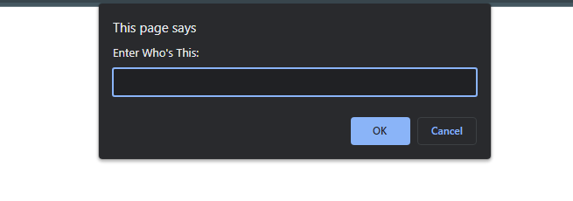

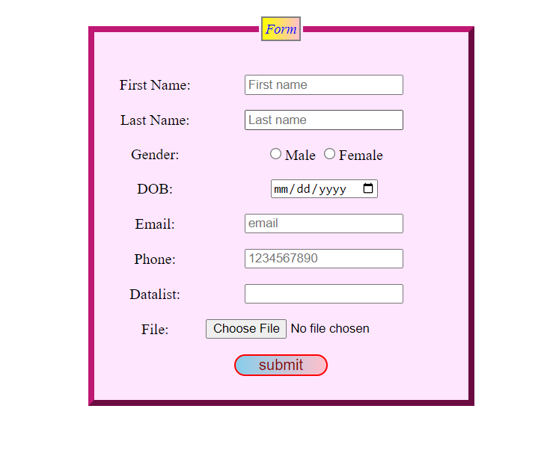

2. Write the code which outputs prime numbers in the interval from 2 to n. Reading input(n)

from user at runtime.(prompt, if,while or for).

Code:

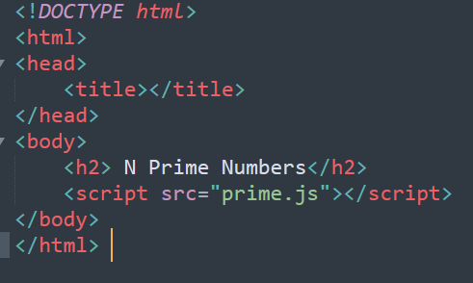

**Javascript code:-**

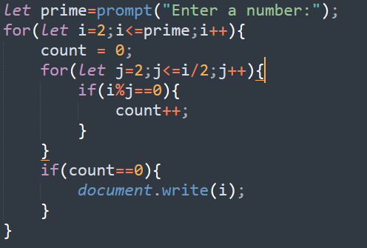

**OUTPUT:-**

